The following are the basic steps to setup Splunk locally for use –

1. Go to [www.splunk.com](http://www.splunk.com)
2. Click on Free Splunk



1. Click on Free Download under Splunk Enterprise



1. Click on the Windows OS



1. Click on the .msi file under OS version 64 bit

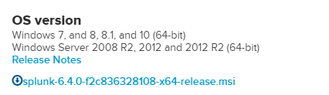

1. Sign up or login if you already have splunk credentials – which will download the file

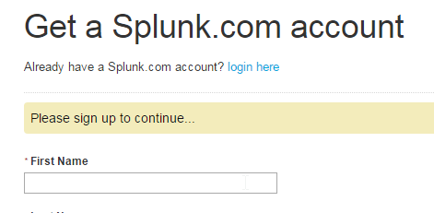

1. Install the Splunk from the downloaded .msi file
2. Once downloaded, please access - <http://localhost:8000/> and follow the instructions to login to the app

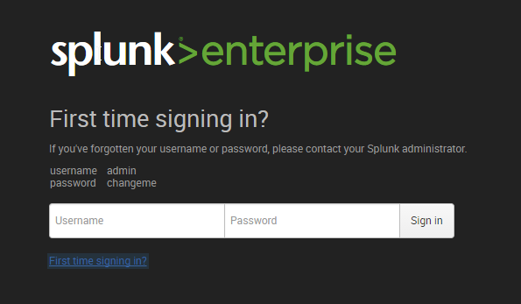

1. For data setup from any table of any DB we need to install a plug in – Splunk DB connect v1, on the landing page – click on settings icon

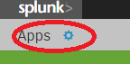

1. Click on Browse More App



1. Search for Splunk DB Connect 1 and install the App

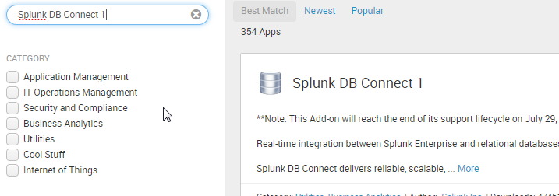

1. If the request gets timed out – there is another way to download this file –
   1. Go to <https://splunkbase.splunk.com/app/958/>
   2. Download the file post login

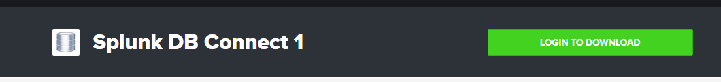

* 1. Once the file is downloaded, come back to home page of Splunk – Click on Apps settings



* 1. Click on install App from file



* 1. Browse for installed App and Upload

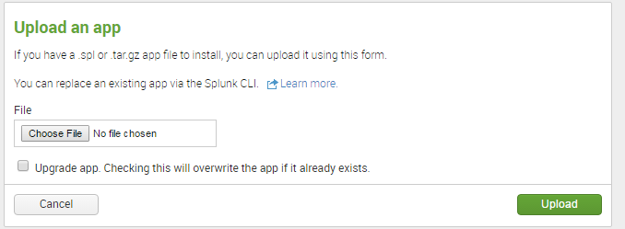

1. Once uploaded or installed if Splunk prompts for restart- Please restart
2. Then on the home page you would see App as below

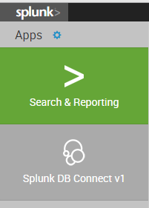

1. Click on Splunk DB Connect and it will prompt for Java Set up. Please provide Java Home Path and Save

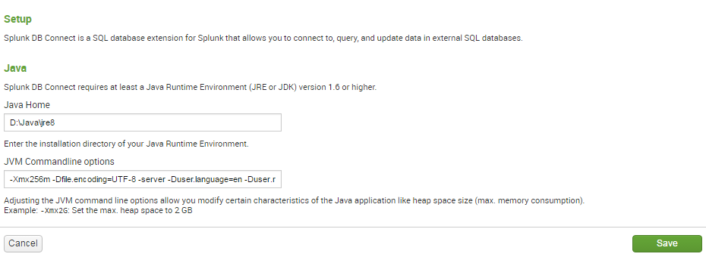

1. Before proceeding further, please copy odbc6.jar under $JAVA_HOME$/jre/lib/ext folder
2. On the Splunk end you would see DB Connect home page. Click on Database Connections to setup connections to any DB

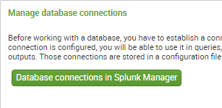

1. Click on New and it will prompt properties page.

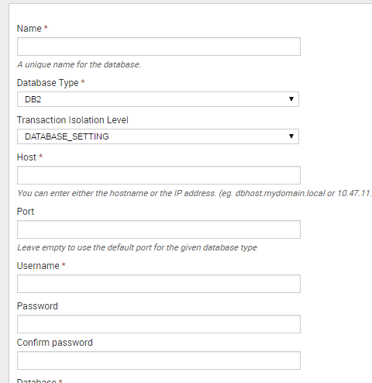

1. Provide required information and choose Database Type as “Oracle” and Save the configuration
2. To test the connectivity, go to Splunk DB Connect home page – Click on DB Query

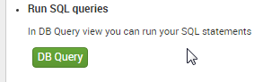

1. Select the DB, Write any sample SQL query and run – which will fetch the results

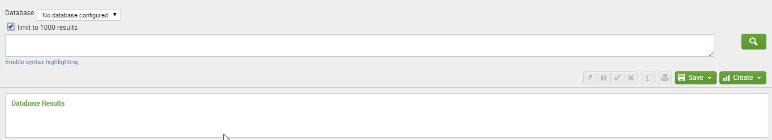

1. To Grab the data from any table of DB Configured, get back to Splunk Db Connect Home Page and Click on Add Database Inputs

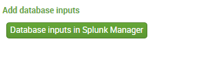

1. Click on New and a configuration page will pop-up. Provide the configurations as required- For example
   1. Provide any name – consider server stats
   2. Input type – Tail (for incremental data)/Dump (for full table data)
   3. Select DB
   4. Click Specify Query – Provide query in the format

SELECT * FROM my_table {{WHERE $rising_column$ >?}}

* 1. Specify raising column – which is used as identifier for incremental pulling of data into splunk
  2. Provide source type and host as any name which will act as identifier to your data pulled. If index is not provided it will take default index
  3. Output format could be key value/CSV/other based on the needs
  4. Provide interval in cron format (0,30 * * * *) specifies it will look for data evert=y 30 min. If this is kept empty- it will be set to default

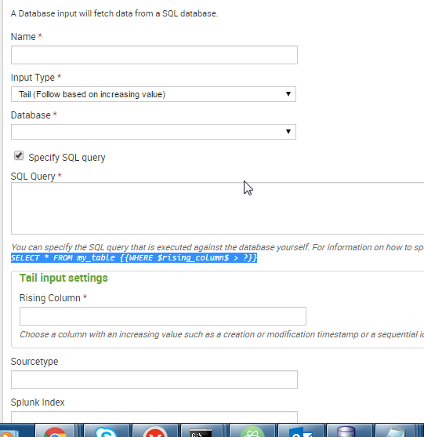

1. One the data is configured – to see the data into splunk – Go to Splunk home page and click on Search and reporting.
2. Click on Data summary and it will display the source type/index/host which you had specified.

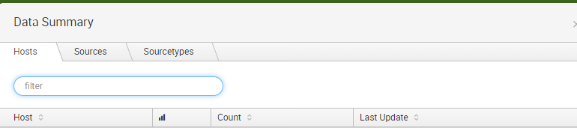

1. Click on your source type- you will be able to see the data which is indexed data
2. Now based on your needs generate reports/dashboards/extract data as raw/table/list. Use these as per your needs.